

Intelligent Airport Baggage Tracking And Logistics Management System

A REPORT

In
CSA1012 –Software Engineering
Submitted in the partial fulfillment for the award of the degree

Of
BACHELOR OF ENGINEERING IN
INFORMATION TECHNOLOGY
Submitted by:
K.Nanda Kishore
192411161

Supervisor/Advisor Name:
Dr. K. Anita Devamani, Professor/CSE

SAVEETHA INSTITUTE OF MEDICAL AND TECHNICAL SCIENCES CHENNAI-602105

Table of Contents:

Section | Title | Page
1 | Introduction | 2
1.1 | Purpose | 2
1.2 | Scope and Assumptions | 2
2 | Requirement Analysis — CI/CD Needs | 2
3 | Pipeline Architecture Overview | 3
3.1 | Workflow Walkthrough — Commit to Deployment | 3
4 | Pipeline Stages — Detailed Description | 4
5 | Tools and Technology Selection | 5
6 | Automated Testing Strategy | 6
7 | Code Quality, Security and Compliance Checks | 7
8 | Deployment Strategy | 8
8.1 | Environments | 8
8.2 | Release Strategy | 9
9 | Notifications and Monitoring | 9
10 | Rollback Mechanism | 10
11 | Sample Pipeline Configuration (Illustrative) | 11
12 | Domain-Specific Risk Considerations | 12
13 | Conclusion | 13

Intelligent Airport Baggage Tracking and Logistics Management System

1. Introduction

This document presents the design of a Continuous Integration and Continuous Deployment (CI/CD) pipeline for the Intelligent Airport Baggage Tracking and Logistics Management System — an IoT-, AI-, and cloud-enabled platform that continuously tracks passenger baggage and manages baggage movement across airport check-in counters, security screening areas, conveyor systems, sorting zones, aircraft loading areas, arrival terminals, and baggage-claim areas.

Because the platform directly affects baggage security, passenger experience, airport operations, and logistics efficiency, the CI/CD pipeline is designed to deliver frequent and reliable software releases without interrupting real-time baggage tracking.

The pipeline automates code integration, building, testing, security analysis, containerisation, deployment, monitoring, and rollback. It also supports periodic AI/ML model updates for baggage-delay prediction, route-deviation detection, and misplaced-baggage identification.

1.1 Purpose

The purpose of this pipeline is to automate the software development and deployment process so that new features, bug fixes, tracking improvements, AI/ML model updates, and security patches reach production quickly and safely.

The pipeline aims to:

Detect defects at the earliest stage.

Maintain continuous baggage tracking during deployments.

Automate testing and security verification.

Reduce manual deployment errors.

Support rapid rollback when failures occur.

Maintain complete deployment traceability.

Support multiple airports, terminals, airlines, and baggage-handling facilities.

1.2 Scope and Assumptions

The following assumptions are made:

The system consists of independently deployable microservices such as:

Baggage Registration Service

RFID/Barcode Tracking Service

Baggage Routing Service

Delay Detection Service

AI Prediction Service

Notification Service

Reporting Service

Web/Mobile Dashboard

Source code is hosted using GitHub or GitLab.

A trunk-based or short-lived feature-branch development model is used.

Pull-request review is mandatory before merging changes.

The system is containerised using Docker.

Kubernetes is used for container orchestration.

Three environments are maintained:

Development

Staging/QA

Production

Synthetic baggage and scanner data are used in development and staging.

Production contains live baggage and airport operational data.

2. Requirement Analysis — CI/CD Needs

Analysis of the Intelligent Airport Baggage Tracking and Logistics Management System identifies the following CI/CD requirements:

Frequent and Safe Releases

Baggage tracking logic, routing rules, notification services, and AI/ML prediction models may be updated regularly. These changes must be automatically tested before deployment.

Continuous Availability

Airport baggage tracking operates continuously. Deployments should not interrupt baggage scan processing or tracking services.

Fast Feedback on Defects

A defect in baggage tracking or route-detection logic can cause baggage to become misplaced or incorrectly reported. Therefore, failures must be detected as early as possible.

Strong Security

The system processes passenger, baggage, airport, and operational information. Automated security scanning must therefore be performed before production deployment.

Safe Rollback

If a new release causes tracking failures, the system must quickly return to the previous stable version.

Multi-Airport Scalability

The platform should support multiple airports, terminals, airlines, and baggage-handling zones. Infrastructure must therefore be provisioned consistently using Infrastructure-as-Code.

Complete Traceability

Every production release should be traceable to:

Source-code commit

Developer

Reviewer

Test results

Security results

Release approver

Deployment version

3. Pipeline Architecture Overview

The CI/CD pipeline consists of two major phases:

Continuous Integration (CI)

The CI phase starts when a developer commits code and creates a pull request. After review and merge, the pipeline:

Builds the application.

Runs unit and component tests.

Performs code-quality analysis.

Performs security scanning.

Builds Docker images.

Scans container images.

Pushes approved images to a private registry.
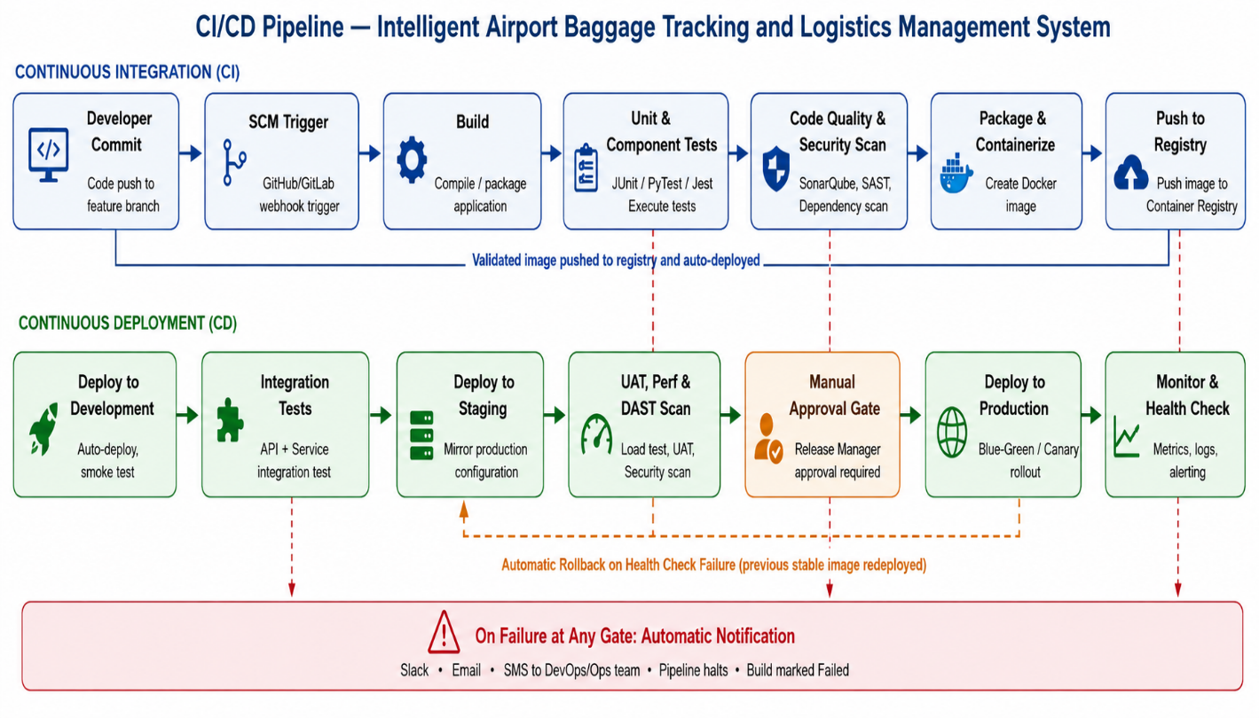

Continuous Deployment (CD)

The CD phase promotes the same validated image through:

Development → Staging/QA → Production

Automated quality gates are applied between environments.

A failed quality or security gate stops the pipeline. Production health-check failure triggers automatic rollback.

3.1 Workflow Walkthrough — Commit to Deployment

A developer creates a feature branch and commits code.

A pull request is created for review.

After approval and merge, the CI pipeline starts automatically.

The application is built and unit tests are executed.

Static code-quality and security analysis are performed.

A versioned Docker image is created.

The container image is scanned for vulnerabilities.

The image is pushed to a private container registry.

The application is automatically deployed to Development.

Smoke and integration tests are executed using simulated baggage and scanner events.

The same validated image is promoted to Staging.

UAT, performance, regression, and security tests are performed.

A release manager approves the production release.

Production deployment is performed using Canary or Blue-Green deployment.

The system is continuously monitored.

If serious problems are detected, the previous stable version is automatically restored.

4. Pipeline Stages — Detailed Description
Stage | Purpose | Exit Criteria
1. Source Code Management | Version control, branching, and pull-request review | PR approved and branch protection rules passed
2. Build | Compile code and resolve dependencies | Build completes without errors
3. Unit & Component Tests | Test individual services and functions | All tests pass; coverage ≥ 80%
4. Code Quality & Security Scan | Detect code defects and vulnerabilities | Quality gate passed; no critical/high vulnerabilities
5. Package & Containerize | Create versioned Docker images | Image created and tagged with commit SHA
6. Container Image Scan & Registry Push | Detect container vulnerabilities and store approved image | No critical vulnerabilities; image pushed
7. Deploy to Development | Automatically deploy new version | Deployment and smoke test successful
8. Integration Tests | Validate service-to-service communication | Integration tests pass
9. Deploy to Staging | Deploy to production-like environment | Staging environment healthy
10. UAT, Performance & DAST | Validate business behaviour, performance, and runtime security | UAT approved and test targets satisfied
11. Manual Approval Gate | Release manager reviews results | Approval recorded
12. Deploy to Production | Gradual production deployment | Production health checks pass
13. Monitor & Health Check | Continuously monitor system behaviour | Metrics remain within defined limits

5. Tools and Technology Selection
Stage | Recommended Tool(s) | Justification
Source Code Management | GitHub / GitLab | Provides version control, pull requests, branch protection and webhooks
CI/CD Orchestrator | GitHub Actions / Jenkins | Automates CI/CD workflows
Build | Maven / Gradle / npm | Supports common application technologies
Unit Testing | JUnit 5 / Mockito / Jest | Supports automated unit and component testing
Code Coverage | JaCoCo / Istanbul | Measures test coverage
SAST | SonarQube / Semgrep | Detects code-quality and security issues
Dependency Scanning | OWASP Dependency-Check / Snyk | Detects vulnerable dependencies
Secret Scanning | GitLeaks | Detects accidentally committed credentials
Containerization | Docker | Provides consistent application environments
Container Scanning | Trivy / Grype | Detects container CVEs
Container Registry | Amazon ECR / Private Docker Registry | Stores versioned container images
Infrastructure as Code | Terraform | Provides repeatable infrastructure provisioning
Container Orchestration | Kubernetes | Supports scaling and self-healing
API Testing | Postman / Newman / RestAssured | Automates API and tracking-service testing
Performance Testing | k6 / Apache JMeter | Simulates large numbers of baggage tracking events
DAST | OWASP ZAP | Detects runtime application vulnerabilities
Deployment | Argo CD / Spinnaker | Supports controlled deployments and rollback
Monitoring | Prometheus + Grafana | Provides real-time system metrics
Logging | ELK / OpenSearch | Centralised log collection and analysis
Notifications | Email / SMS / Slack / PagerDuty | Provides rapid failure notification
Secrets Management | HashiCorp Vault / AWS Secrets Manager | Secure storage of credentials and API keys

6. Automated Testing Strategy

Testing is organised in layers so that fast and inexpensive tests execute first, while slower and more comprehensive tests execute later.
Test Type | Pipeline Stage | What It Validates
Unit Testing | CI — Build | Baggage ID validation, route validation and business logic
Component Testing | CI — Build | Individual baggage-tracking service behaviour
Static Analysis | CI — Security | Code quality and security vulnerabilities
Dependency Scanning | CI — Package/Scan | Vulnerable third-party libraries
Container Scanning | CI — Package/Scan | Vulnerabilities inside Docker images
Integration Testing | CD — Development | Communication between tracking, routing and notification services
Regression Testing | CD — Development/Staging | Existing baggage-tracking functionality remains operational
Performance Testing | CD — Staging | Large-scale baggage tracking and event processing
DAST | CD — Staging | Runtime security vulnerabilities
UAT | CD — Staging | Airport staff/business acceptance
Smoke Testing | Post-deployment | Critical tracking functionality after deployment

Examples of Automated Tests

The pipeline can automatically test:

Baggage registration.

RFID/barcode event processing.

Duplicate baggage ID detection.

Baggage location updates.

Route deviation detection.

Delayed baggage detection.

Missing baggage detection.

Notification delivery.

Passenger tracking dashboard.

AI-based delay prediction.

Report generation.

Role-based access control.

API authentication.

7. Code Quality, Security and Compliance Checks

The following checks are applied automatically:

Quality Gate

SonarQube checks:

Code quality.

Maintainability.

Bugs.

Code duplication.

Critical coding issues.

SAST

Security analysis checks for:

SQL injection.

Authentication weaknesses.

Hard-coded credentials.

Insecure APIs.

Unsafe input processing.

Dependency Scanning

Third-party dependencies are scanned for known vulnerabilities.

Secret Scanning

GitLeaks or a similar tool checks for:

API keys.

Passwords.

Access tokens.

Database credentials.

Container Security

Docker images are:

Built using minimal base images.

Scanned for vulnerabilities.

Run using non-root users where possible.

Deployed using least-privilege permissions.

Encrypted Communication

TLS is enforced for communication between:

RFID/barcode scanners and backend.

Backend microservices.

Cloud services and dashboards.

Mobile applications and APIs.

Immutable Audit Trail

Every deployment records:

Commit ID.

Build number.

Test results.

Security results.

Approver.

Deployment time.

Production version.

Rollback information.

8. Deployment Strategy

8.1 Environments
Environment | Purpose | Deployment Trigger | Data
Development | Rapid developer feedback | Automatic after merge | Synthetic baggage data
Staging / QA | Production-like testing | Automatic after Dev tests | Synthetic/anonymised data
Production | Live airport operations | Manual approval | Live baggage data

Development

The Development environment is used for:

Build validation.

Unit testing.

Integration testing.

Initial smoke testing.

Staging / QA

The Staging environment mirrors production as closely as possible and is used for:

UAT.

Performance testing.

Regression testing.

Security testing.

AI/ML validation.

Production

Production contains the live airport baggage-tracking system.

Production deployment occurs only after:

Automated tests pass.

Security checks pass.

Performance requirements are satisfied.

UAT is approved.

Release manager approval is recorded.

8.2 Release Strategy

A Canary deployment is recommended as the default strategy.

For example:

5% → 25% → 50% → 100%

A new release is initially provided to a small portion of airport traffic. The system monitors:

Baggage event processing errors.

API response time.

Scanner event latency.

Tracking failures.

Notification failures.

CPU and memory usage.

If all metrics remain within the defined limits, deployment continues.

If serious errors are detected, deployment stops and the previous stable version is restored.

For major infrastructure releases, Blue-Green deployment can be used.

9. Notifications and Monitoring

The CI/CD system sends notifications whenever:

Build fails.

Unit tests fail.

Security scanning fails.

Container scanning detects a critical vulnerability.

Integration tests fail.

Staging deployment fails.

UAT is rejected.

Production deployment fails.

Production health checks breach thresholds.

Automatic rollback occurs.

Notifications can be delivered through:

Email.

Slack.

SMS.

PagerDuty.

Prometheus and Grafana monitor:

Baggage tracking latency.

API response time.

Error rate.

Scanner event processing.

Notification success rate.

CPU usage.

Memory usage.

System availability.

10. Rollback Mechanism

Automated Rollback

If production health checks detect:

High error rates.

Tracking-event failures.

Increased response latency.

Notification failures.

Service crashes.

the deployment system automatically redirects traffic to the previous stable release.

Manual Rollback

A release manager can manually select a previous version and perform an immediate rollback.

Database Migration Safety

Database changes follow a backward-compatible expand-and-contract strategy so that rolling back application code does not cause database incompatibility.

Rollback Audit Logging

Every rollback records:

Date and time.

Application version.

Previous version.

Reason for rollback.

Triggering metric.

Person initiating rollback.

11. Sample Pipeline Configuration — Illustrative

A simplified GitHub Actions workflow for the Intelligent Airport Baggage Tracking and Logistics Management System can contain the following stages:

name: Airport Baggage CI/CD

on:

push:

branches:

- main

jobs:

build-test:

runs-on: ubuntu-latest

steps:

- name: Checkout Code

uses: actions/checkout@v4

- name: Build Application

run: ./build.sh

- name: Run Unit Tests

run: ./test.sh

- name: Code Quality Scan

run: sonar-scanner

- name: Build Docker Image

run: docker build -t baggage-tracking:${{ github.sha }} .

- name: Security Scan

run: trivy image baggage-tracking:${{ github.sha }}

- name: Deploy to Development

run: kubectl apply -f deployment-dev.yaml

- name: Run Integration Tests

run: ./integration-test.sh

This configuration is illustrative; the actual commands depend on the technologies selected for the implemented system.

12. Domain-Specific Risk Considerations
Risk | Pipeline Safeguard
Defective release causes baggage tracking failure | Mandatory unit, integration and regression tests before deployment
Baggage location information is incorrectly processed | Automated tracking and route-validation tests
AI model incorrectly predicts baggage delay | ML model validation and regression testing
Sensitive passenger/baggage data is exposed | SAST, dependency scanning, DAST and encryption
Unauthorized change reaches production | Branch protection and mandatory pull-request approval
Deployment interrupts baggage tracking | Canary/Blue-Green deployment
New version causes scanner-event failures | Post-deployment smoke and health checks
Production failure continues for a long period | Automatic rollback
System cannot handle airport-scale baggage volume | Performance and load testing
Deployment cannot be traced during an audit | Immutable CI/CD logs and approval records
Notification service fails | Automated notification and fallback testing
Infrastructure configuration differs between environments | Terraform and Infrastructure-as-Code

13. Conclusion

This CI/CD pipeline design provides an automated and controlled path for the Intelligent Airport Baggage Tracking and Logistics Management System from source-code commit to production deployment.

The pipeline covers source-code management, automated builds, unit and integration testing, code-quality analysis, security scanning, containerisation, staging validation, performance testing, deployment approval, production rollout, monitoring, and automatic rollback.

Layered testing ensures that defects in baggage registration, RFID/barcode tracking, baggage routing, delay detection, notification services, AI prediction, and reporting are identified before reaching live airport operations.

The use of Docker and Kubernetes provides deployment consistency and scalability, while Terraform supports repeatable infrastructure provisioning. Security tools such as SonarQube, Semgrep, Trivy, OWASP ZAP, and GitLeaks provide automated protection against common software and infrastructure vulnerabilities.

The recommended Canary and Blue-Green deployment strategies minimise the impact of defective releases. Continuous monitoring using Prometheus and Grafana, combined with automatic rollback, ensures that the baggage tracking platform remains available and reliable.

Overall, the proposed CI/CD pipeline enables the airport baggage system to achieve faster releases, improved software quality, stronger security, better scalability, continuous availability, and complete deployment traceability, supporting reliable baggage tracking and efficient airport logistics management.

